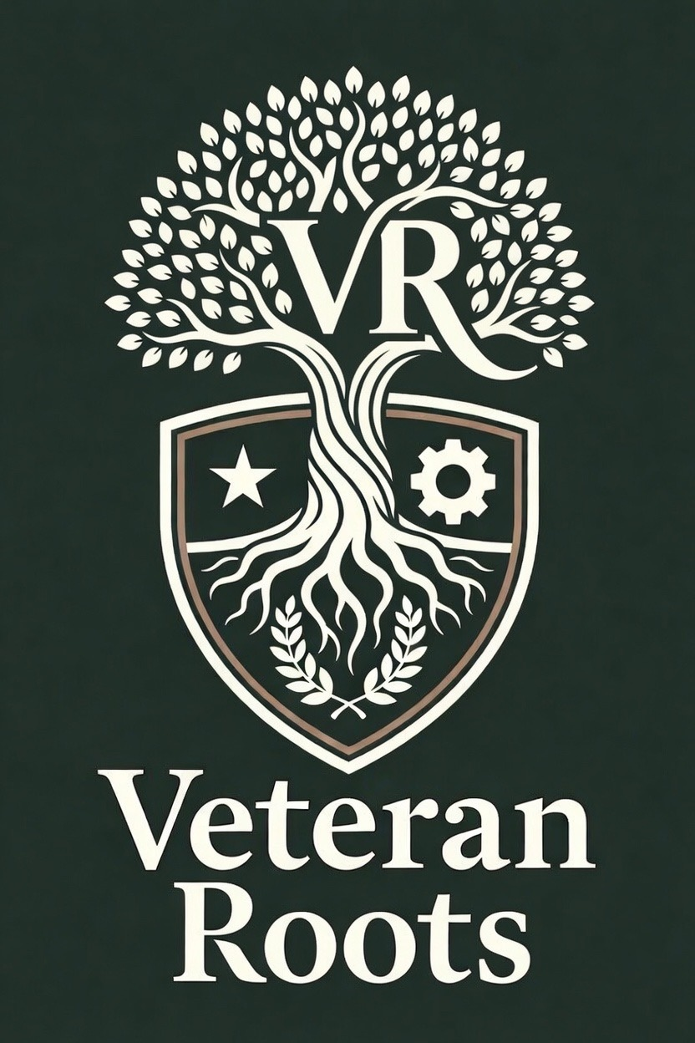 | VETERAN ROOTS LLC  Service-Disabled Veteran-Owned & Veteran-Owned Small Business | Wholesale Supply & Distribution

COMPANY DATA  UEI: MR15Q9159F16  CAGE Code: 20Z84  Business Address:  1554 Shadowstone Cir, Winder, GA 30680 | POINT OF CONTACT  Joseph Palmer – Business Development Lead  Email: veteranrootsga@gmail.com  Phone: (770) 560-6735  Website: veteranroots.netlify.app

NAICS CODES  Primary:  • 326211 – Tire Manufacturing (except Retreading)  Additional:  • 339112 – Surgical and Medical Instrument Manufacturing  • 339113 – Surgical Appliance and Supplies Manufacturing  • 339114 – Dental Equipment and Supplies Manufacturing  • 325413 – In-Vitro Diagnostic Substance Manufacturing  • 423120 – Motor Vehicle Supplies and New Parts Merchant Wholesalers  • 336310 – Motor Vehicle Gasoline Engine and Engine Parts Manufacturing  • 336320 – Motor Vehicle Electrical and Electronic Equipment Manufacturing  • 336330 – Motor Vehicle Steering and Suspension Components Manufacturing  • 336340 – Motor Vehicle Brake System Manufacturing  • 336350 – Motor Vehicle Transmission and Power Train Parts Manufacturing  • 336360 – Motor Vehicle Seating and Interior Trim Manufacturing  • 336390 – Other Motor Vehicle Parts Manufacturing  • 423450 – Medical, Dental, and Hospital Equipment and Supplies Merchant Wholesalers | PSC CODES  Primary:  • 2610 – Tires and Tubes, Pneumatic, except Aircraft  Additional:  • 8105 – Bags and Sacks  • 2590 – Miscellaneous Vehicular Components  • 6525 – Imaging Equipment and Supplies: Medical, Dental, Veterinary  • 6515 – Medical and Surgical Instruments, Equipment, and Supplies  • 2530 – Vehicular Brake, Steering, Axle, Wheel, and Track Components  • 6520 – Dental Instruments, Equipment, and Supplies  • 2310 – Passenger Motor Vehicles  • 6530 – Hospital Furniture, Equipment, Utensils, and Supplies

CORE COMPETENCIES
• Wholesale distribution and drop-shipping of general merchandise
• Tire and automotive supply distribution for government fleet needs
• Medical supplies and sundries distribution
• Rapid sourcing and fulfillment through established supplier partnerships
• Reliable, compliant order processing for federal purchasing requirements

CERTIFICATIONS
• SDVOSB – Service-Disabled Veteran-Owned Small Business
• VOSB – Veteran-Owned Small Business
• Active & Verified in SAM.gov
• Registered – SAM.gov Disaster Response Registry
FULFILLMENT MODEL
Veteran Roots LLC operates on a wholesale and drop-ship model, sourcing from established supplier partnerships to deliver reliably against federal purchase orders without carrying heavy inventory overhead — keeping pricing competitive and fulfillment fast.
COMPANY OVERVIEW
Veteran Roots LLC is a certified Service-Disabled Veteran-Owned Small Business (SDVOSB) and Veteran-Owned Small Business (VOSB) based in Winder, Georgia, specializing in wholesale distribution and drop-shipping of general merchandise, tires, and medical supplies to federal agencies. Founded on the principles of reliability, integrity, and service, Veteran Roots LLC is built to support federal supply needs with the speed and accountability that comes from veteran leadership.
The company is positioned to support recurring and one-time procurement needs across VA medical centers, military installations, and other federal facilities, with a focus on commercial off-the-shelf items that can be sourced and delivered quickly and reliably.
WHY VETERAN ROOTS LLC
• Veteran-owned and veteran-led — SDVOSB/VOSB certified and actively registered in SAM.gov
• Lean, responsive operation built for fast turnaround on supply orders
• Multidisciplinary leadership background spanning business development, logistics, and hands-on trades
• Committed to long-term federal partnership — not a one-time vendor
• Positioned to support VA Veterans First Contracting Program set-aside and sole-source opportunities
LEADERSHIP
John Facik — Managing Member (51%)
John Facik serves as Managing Member of Veteran Roots LLC, overseeing daily operations, supplier relationships, and contract fulfillment.
Senator Boem — Member (49%)
Senator Boem serves as a co-owner of Veteran Roots LLC, supporting the company’s strategic direction and growth.
PAST PERFORMANCE
Veteran Roots LLC is a newly certified SDVOSB/VOSB actively building its federal contracting portfolio. The company’s leadership brings a demonstrated record of executing complex, multi-step processes with precision and speed — including the company’s own formation, SAM.gov registration, and SDVOSB/VOSB certification, completed start to finish in under three months. We welcome the opportunity to demonstrate this same reliability on federal supply contracts, beginning with smaller-dollar and sole-source opportunities.
Veteran Roots LLC | 1554 Shadowstone Cir, Winder, GA 30680 | veteranrootsga@gmail.com | veteranroots.netlify.app | UEI: MR15Q9159F16 | CAGE: 20Z84

